**KWAME NKRUMAH UNIVERSITY OF SCIENCE AND TECHNOLOGY**



**COLLEGE OF ENGINEERING**

**DEPARTMENT OF COMPUTER ENGINEERING**

PROJECT TITLE: THE SMART SCHOOL ADMINSTRATIVE SYSTEM

Project submitted in partial fulfilment for a Degree in Bachelor of Science (BSc.) in

Computer Engineering

By

ELI BANSA AND PRISCILLA ADJEI

SUPERVISOR: DR. SERLOM KLOGO

MARCH 2024

# Content

# DECLARATION

We affirm that this submission represents our independent effort in pursuit of a BSc degree. We assure that, to the best of our knowledge, it does not incorporate any content previously published by others.

# ACKNOWLEDGEMENT

This project wouldn't have been possible without the support and contributions of several individuals and resources. We are sincerely grateful to:

* **Our project supervisor, Dr. Serlom Klogo:** His guidance, advice, and unwavering patience throughout the project development were invaluable. His encouragement and dedication played a crucial role in our success.
* **KNUST:** We are thankful for the opportunity to participate in this project as part of our Bachelor of Science (BSc) in Computer Engineering program. The institution's support and resources were essential to our work.
* **Our friends and classmates:** Their collaboration and assistance throughout the project journey were greatly appreciated. Their support and camaraderie helped us overcome challenges and achieve our goals.

**Closing:**

We are proud of the work we accomplished and believe it has made a meaningful contribution to education. We are grateful for the opportunity to learn and grow through this experience and for the support of those who helped us along the way.

.

# ABSTRACT

The evolution of technology has revolutionized the educational landscape, offering unprecedented opportunities for enhancing school management and improving educational outcomes. In this context, the concept of data-informed decision-making emerges as a powerful tool for optimizing administrative processes and driving continuous improvement in school management. Our final year project focuses on the development and implementation of a Smart School Administrative System that leverages data to facilitate informed decision-making and drive improvements in school management. The system is designed to collect diverse data points from various sources within the school environment, including student records, attendance data, financial transactions, and academic performance metrics. Through advanced analytical techniques such as machine learning algorithms and statistical methods, the collected data is analyzed to derive meaningful insights, identify trends, correlations, and areas for improvement within the school administration. These insights serve as a foundation for informed decision-making, enabling administrators and educators to allocate resources effectively, plan curriculum, manage staff, and implement evidence-based strategies to enhance student outcomes.

Moreover, the Smart School Administrative System emphasizes ongoing monitoring and evaluation of implemented strategies to assess their effectiveness and facilitate continuous improvement. By regularly analyzing relevant data metrics, administrators can track progress towards organizational goals, identify areas requiring further attention or improvement, and adapt strategies accordingly. In general, our project highlights the significance of adopting data-informed strategies, in managing schools to enhance effectiveness, adjust to evolving environments and cater to the requirements of students, teachers and other stakeholders. By introducing a Smart School Administrative System our goal is to enable schools to streamline their processes, boost efficiency and ultimately enhance results for stakeholders.

Contents

Content 2

DECLARATION 2

ACKNOWLEDGEMENT 3

ABSTRACT 4

CHAPTER 1 6

INTRODUCTION 6

**1.1 Background:** 6

**1.2 Problem Statement:** 7

**1.3 Solution: Smart School Administrative System**: 7

**1.4 Objectives:** 7

**1.5 Objectives Breakdown:** 8

CHAPTER 2 8

Literature Review 8

**2.1 Importance of Effective School administration:** 9

**2.2 Dangers of Making Decisions Purely on Intuition:** 9

**2.3 Why Data-informed Decision Making:** 10

**2.4 Factors affecting student performance:** 10

**2.5 Factors affecting teacher performance:** 11

**2.6 Existing Systems for School Administration:** 12

CHAPTER 3 13

Methodology 13

**3.1 Data Collection, Preparation and Analysis:** 14

**3.1.1 Data Collection:** 14

**3.1.2 Data Cleaning and Preparation:** 14

**3.1.3 Data Analysis:** 14

**3.2 Development Framework:** 14

**3.3 Tools and Frameworks:** 15

**3.3.1 Machine Learning:** 15

**3.3.2 UI Design:** 17

**3.3.3 API Management:** 18

**3.4 Application Flow:** 18

**3.5 Database Overview:** 20

**References** 22

# CHAPTER 1

# INTRODUCTION

## **1.1 Background:**

The education field has undergone changes in the few years due to technological advancements and an increasing focus on data driven methods. Traditional methods of school administration, characterized by manual processes and subjective decision-making, are being replaced by innovative systems that leverage data to inform decision-making and drive improvements in educational outcomes. The transition towards data-informed decision-making in school administration is driven by the recognition of its potential to address longstanding challenges and optimize administrative processes. Historically, schools have faced issues such as inefficient resource allocation, limited insights into student performance, and a lack of adaptability to changing educational landscapes. However, the emergence of smart technologies and analytical tools presents an opportunity to overcome these challenges and revolutionize school management. Our final year project seeks to contribute to this transformative shift by developing and implementing a Smart School Administrative System that harnesses the power of data to facilitate informed decision-making and enhance school management practices. By collecting diverse data points from various sources within the school environment, including student records, attendance data, financial transactions, and academic performance metrics, the system aims to provide administrators and educators with valuable insights into school operations. Through the analytical technique of ML (Machine Learning), the collected data will be analyzed to identify trends, and areas for improvements within administration.

"The Smart school administrative system" would foster informed decision-making, enabling administration to allocate resources effectively, plan curriculums, manage staff, and implement based on evidence to enhance student education.

## **1.2 Problem Statement:**

In today’s changing world of education effective school administration plays a role, in shaping student outcomes. Regrettably numerous educational institutions, especially in Africa, face issues with methods that impede their efficiency and flexibility. These obstacles typically arise from subjective judgments and inadequate incorporation of technology. Such factors place a strain on staff members restrict adaptability and ultimately compromise the experience of students. This project tackles these issues head-on by proposing a new approach to school management. Our vision is a system that leverages modern technology to streamline processes, prioritizes data-informed decision-making, and automates repetitive tasks. This will empower schools to operate with greater efficiency, adapt more readily to evolving educational needs, and ultimately provide students with the best possible learning environment, equipping them for future success.

Below are a few studies that underpins the afore-mentioned problems:

* The Africa Data Revolution Report 2018 highlights challenges related to data access and availability in African education systems. For instance, while there is increasing digitization of education data, access to this data remains limited, hindering its use for decision-making [17]. The graphs below, which were results obtained from the results of the studies highlighted in the 2018 Africa Data Revolution Report clearly depicts this issue. It can be seen that the scores obtained, for each of the features studied, by Africa were well below average. As the features that were studied are related to the public availability of data as well as degree of use of data in various fields, these findings clearly show that Africa is well behind when it comes to deriving insightful benefits from educational data.

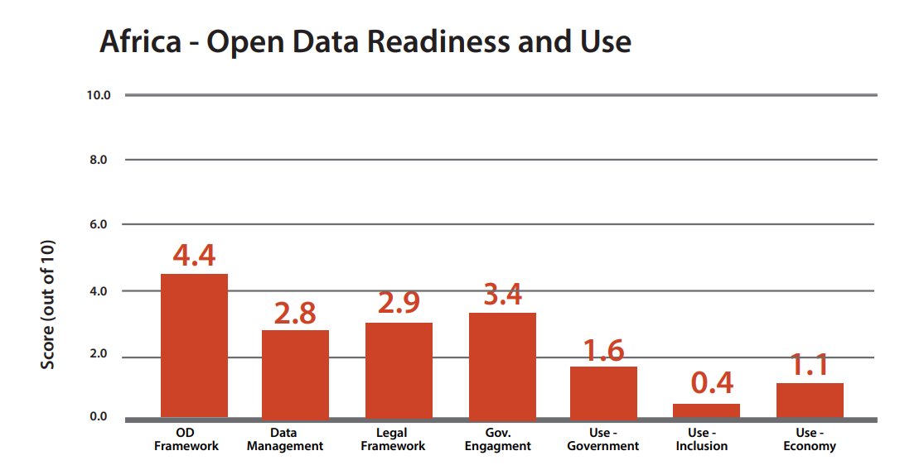

Figure 1 Average open data readiness and use score in Africa

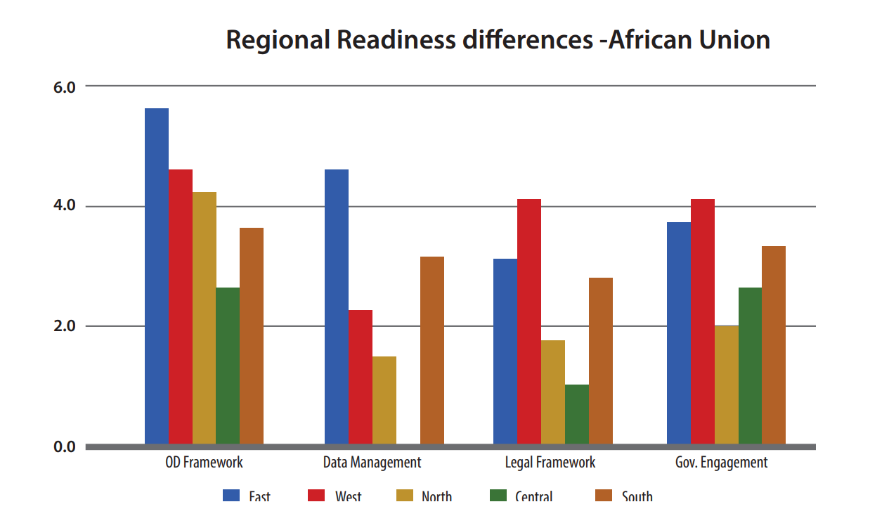

Figure 2 Comparison on open data readiness among the different African Union regions

* According to the Global Partnership for Education (GPE), African educational systems frequently experience problems with data quality, such as missing or erroneous data. Sometimes, uniform data gathering instruments and procedures are lacking, which compromises the accuracy of educational data [18].

## **1.3 Solution: Smart School Administrative System**:

The Smart School Administrative System is a comprehensive platform designed to streamline school management processes through the strategic integration of ML (Machine Learning) and AI (Artificial Intelligence) technologies. By automating tasks such as attendance tracking, student and staff management, and finance management, the system aims to enhance administrative efficiency, improve decision-making, and provide valuable insights for school administrators, teachers, and stakeholders.

The main objective of the system is to promote data-informed decision making in place of traditional, purely intuition-based decision making. The system accomplishes this by offering tools for forecasting teacher and student performance. Apart from its predictive capabilities, the system also provides an understanding of the primary factors that impact both individual students and teachers as well as groups as a whole.

## **1.4 Objectives:**

The objectives of the Smart School Administrative System are multifaceted:

* Gain actionable insights from collected data using ML algorithms, such as grade prediction, financial trends analysis, and teacher performance prediction.
* Enhance the quality of education and school management by leveraging technology to optimize administrative processes and improve decision-making.

## **1.5 Objectives Breakdown:**

The system's objectives are further delineated into specific tasks, including attendance tracking, student and staff management, finance management, grade prediction, and teacher performance prediction. Each objective is aimed at addressing specific challenges in school administration and improving overall efficiency and effectiveness.

# CHAPTER 2

# Literature Review

The realm of educational administration, particularly in developing countries like Ghana, faces significant challenges stemming from outdated administrative processes and reliance on intuitive decision-making. This literature review aims to explore the existing research and scholarly discourse surrounding the transition towards advanced school management through informed decision-making practices. Specifically, the review will address the prevalence of paper-based administrative systems, the implications of intuitive decision-making, and the potential benefits of adopting data-driven approaches in educational settings.

## **2.1 Importance of Effective School administration:**

School administration plays a very crucial role in the school's overall performance. As leaders of their institutions, administrators are responsible for identifying the goals and visions of the school and coming out with clear plans on how to achieve those goals as well as constantly evaluating progress.

Listed below are some roles of school administrators:

**Leadership:**

Administrators must provide a clear vision to guide school improvement efforts.

They are responsible for fostering a positive and supportive school culture that fosters love of learning and high expectations for students.

Research suggests that transformational leadership, which involves inspiring and motivating followers to achieve shared goals, is most effective in promoting school improvement [1].

**Communication:**

Communication is a crucial aspect of improving schools. Administrators need to effectively communicate the school's vision, goals, and progress to all stakeholders, including faculty, students, parents, and the community. Effective communication entails active listening, providing timely feedback, and maintaining transparency.

Research suggests that open and transparent communication enhances

stakeholders' engagement and promotes a sense of ownership in the school improvement

Process.

**Decision Making:**

It can be said that the fate of the school rests on the ability of its administrator to make sound and optimal decisions at every point in time. Each decision made by a school administrator goes a long way to affect the performance of the school, hence administrators are to make sure not to make decisions solely on their intuition but to seek expert advice and make good use of available data.

## **2.2 Dangers of Making Decisions Purely on Intuition:**

Intuition, sometimes known as “gut feeling” is primarily influenced by knowledge and past experiences. Decision making that is based purely on intuition is aptly termed intuition-based decision making.

According to NDM, intuition is “an expression of experience as people build up patterns that enable them to rapidly size up situations and make rapid decisions without having to compare options” [3].

 As its name suggests, this form of decision making does not make use of any past data, hence is not evidence-based. This way of making decisions comes with a number of problems.

The decision maker is unable to correctly assign probabilities to events or even to list all possible outcomes and their combinations. This narrows the scope of the decision maker and most times leads to making suboptimal decisions.

The proliferation of decisions within organizations, both in terms of time and space, results in the formation of chains. These chains involve sub-decisions made at different times and levels, which then intertwine with one another. They are influenced by various justifications and criteria, leading to a multiplication of their effects and outcomes. Decision makers are unable to make clear sense of these convoluted chains if they are to rely solely on their intuition.

Given that decisions are based on the knowledge and experiences of a single person or a small group of people in the intuition-based approach, there exists a high chance of the presence of cognitive bias in whatever decisions are made. Also, the limited and cognitive limitation of human decision makers is another setback in decision making.

Decisions made or actions taken are “satisfycing” in nature. In that a seemingly good decision is good enough for the decision maker. There is a strong feeling of certainty in good ideas that are pulled from one’s intuition, hence the decision-making process usually ends there. The decision maker stops looking for even better solutions and goes with the good enough one. [4]

Despite the drawbacks of intuition-based decision making, people inherently yearn for that approach. There is some fascination towards leaders who are able to who use only their cognitive abilities to steer followers towards the right path, “superheroes” of sorts [2].

## **2.3 Why Data-informed Decision Making:**

Data-informed decision making is a process of using existing data to guide one’s decision making. Before any decisions are made, data is collected and analyzed. Insights are drawn from the analyses of data collected to guide the decision process.

By analyzing data from various sources, organizations can gain a clear understanding of their strengths and weaknesses. This allows organizations to narrow down the target of their attention and to allocate resources in a manner that would lead to the overall growth of the company [9].

Data analysis, a crucial aspect of the data-informed decision-making process allows organizations to identify trends, opportunities and potential risks. During the data analysis phase of the decision-making process, analysts use various statistical tools such as regression analysis, bivariate analysis and the like to bring to light patterns that might be hidden deep within the data. Finding patterns in data is very crucial, as understanding these patterns gives decision makers insight on the major factors affecting their organization’s operation [10].

Evidence derived from data analysis injects a dose of objectivity into the decision-making process. Purely subjective decisions are made based on the knowledge and experiences of a single or very few individuals. This causes a high degree of bias in whatever actions are decided. However, with the presence of facts and figures derived from data analysis, decision makers are forced consider a broader range of possibilities and hence avoid making decisions that are right only to them and those who think like them [11].

## **2.4 Factors affecting student performance:**

The main goal of every educational institution is to give birth to elite individuals that would serve as great assets to their communities and ultimately the world. Student performance in competitive examinations is a primary metric that is used to guide educational institutions towards their ultimate goal. Hence it is necessary that all the factors that affect student performance are brought to light, to aid in decision making processes of administration.

Research has shown that student performance is influenced by a multitude of factors. These factors can be grouped as socio-economic, psychological, environment, demographic and behavioral.

**Socio-Economic Background**:

Individuals can be grouped into three classes on the basis of socioeconomic background; those with high socioeconomic status, middle level socioeconomic status and low socioeconomic status. Research has shown that there is a significant difference between individuals with high socioeconomic status and those with low economic status, but little difference between those belonging to the middle class and those in the high class.

**Demographic**:

Some demographic features that have been found to have a significant influence on student achievement are age, gender and settlement type.

A study found that students from rural areas score lower on academic tests than students from urban areas. The researchers attributed this to the fact that students in rural areas don’t have access to the same level of coaching and learning resources as urban students [5].

Research has found that age also plays a fairly significant role in student performance. Older students tend to perform slightly better, likely due to their increased cognitive development and maturity [5].

Some studies have shown that gender does play a role in academic achievements of students but not at every level of education, and that generally males perform better in science and math topics compared to their female counterparts [6].

**Environmental**:

Student performance is positively impacted by supportive home environments, which include parental involvement in school, availability of educational resources, and a comfortable place to study [8].

**Behavioural**:

Researches made into student performance prediction have brought to light the crucial role that behavioral aspects of students affect their academic performance - “We confirmed that the behavioral feature is so crucial that the accuracy reaches 0.7905 without other features except behavioral feature” [7]. Some behaviors that were found to have positive correlation with student performance were:

* Activeness in class discussions.
* Frequency of raising hands to answer questions during class
* Frequency of learning resource visits

## **2.5 Factors affecting teacher performance:**

Teachers are the ones who are responsible for giving students most of the training they require in life. It can be said that students spend more times learning from their teachers than from parents. Since teachers play a pivotal role in the development of students, it is crucial to gain insights into the various factors that affect their performance.

The quality and relevance of teacher training and professional development play a critical role in shaping teacher performance. Strong programs can equip educators with the knowledge, skills, and strategies they need to be effective in the classroom. [12]

Teacher effectiveness and student outcomes are influenced by various factors, including classroom organization, disciplining tactics, and the general learning environment [13].

Teaching years of experience is another influencing factor of teacher performance. Experienced teachers often demonstrate higher effectiveness. The longer one has worked as a teacher, the more they learn to handle students of different backgrounds. These teachers are able to adapt well to different environments with different crops of students and more clearly ascertain the needs of the students [14].

Teachers' ages might affect their effectiveness; younger educators frequently bring new ideas and vitality, while more experienced educators may possess greater knowledge and insight.[15]

## **2.6 Existing Systems for School Administration:**

1. Traditional Manual Systems:

* Many schools currently rely on manual methods for administrative tasks such as attendance tracking, student management, and finance management.
* These systems involve paper-based processes, spreadsheets, and manual data entry, which can be time-consuming and prone to errors.

2. Basic School Management Software:

* Some schools may already use basic school management software to automate certain administrative tasks.
* These systems typically offer functionalities such as attendance tracking, student information management, and basic reporting capabilities.
* However, they lack features for performance prediction and analysis

3. Enterprise Resource Planning (ERP) Systems:

* Larger educational institutions may utilize ERP systems to manage various aspects of school administration, including finance, human resources, and student information.
* ERP systems offer comprehensive functionalities and integration capabilities across different departments.
* However, they may not be tailored specifically for the unique needs of schools or incorporate advanced ML and AI technologies.

4. Learning Management Systems (LMS):

* Some schools use LMS platforms to manage online learning activities, course materials, and assessments.
* LMS systems facilitate communication between teachers and students, assignment submission, and grading.
* While LMS systems focus primarily on academic aspects, they may lack features for overall school management and administrative tasks.

5. Customized Software Solutions:

* Some schools may have developed or commissioned customized software solutions tailored to their specific administrative needs.
* These systems may offer more flexibility and customization options compared to off-the-shelf software.
* However, they may require significant investment in development and maintenance.

By evaluating these existing systems, the Smart School Administrative System project can identify gaps and opportunities for improvement, ensuring that the final solution effectively addresses the unique needs of schools and leverages ML and AI technologies to streamline administrative processes and enhance decision-making capabilities.

# CHAPTER 3

# Methodology

This section gives a comprehensive overview into the development lifecycle of the Smart School Administrative System. This section begins with a brief overview of the data collection methods and delves into the various analytical approaches that were used to derive insights from the collected. This section then moves on to talk about the development framework adopted during the developing stages of the system. A brief overview of each of the tools and frameworks utilized in the software is then given. The section ends with a basic overview of the application’s flow.

## **3.1 Data Collection, Preparation and Analysis:**

### **3.1.1 Data Collection:**

Ideally collecting primary data from local high schools would be more representative of the scope of the project, however ethical restrictions and inefficient data collection in those institutions are a setback in that regard. However, online sources such as Kaggle, offer a rich source of secondary data. Though most of the data is foreign, the features used within them clearly reflect the studies made in their fields. Take student performance prediction for example. Most of the publicly available sets reflect the findings made by numerous researchers. The features used within the datasets, socioeconomic features, behavioural features, demographic features and environmental features are clearly results of extensive research into the factors affecting student performance.

### **3.1.2 Data Cleaning and Preparation:**

After any data is collected, it needs to go through the processes of cleaning and preparation. Data collection is mostly done by human hands, hence is error-prone. Data collectors might forget to key in some values or they might incorrectly input some values. The data cleaning process involves sifting through the datasets feature by feature in order to find these errors and correct them. Data cleaning ensures there are no missing values within the datasets. It also ensures format consistency (eg. date format for each sample is consistent).

The process of data preparation involves changing the format of the various values of the features to ensure that the data can be processed by whichever tools it is going to be used with.

### **3.1.3 Data Analysis:**

This process would involve looking into the collected data to derive insights and to compare those insights with results obtained from research studies.

The data analysis process would begin with a broad overview of the entire dataset. This would mainly include looking at the feature names and their respective values in order to get a general idea of the nature of the data under study. Statistical tools such as KDE plots, bivariate and multivariate analysis would be used to gain even more insight into the nature of the dataset. Ideally, the results from the analysis should clearly reflect the findings made in this paper.

## **3.2 Development Framework:**

This project adopts the agile framework for its development lifecycle.

Agile is a project management methodology that emphasizes sprints, which are brief, iterative development cycles.   
Teams complete planning, programming, testing, and review phases in each sprint to gradually deliver functional features of the project.   
Agile places a strong emphasis on teamwork and ongoing stakeholder feedback, which gives teams the flexibility to adjust to shifting priorities and requirements.

The development of the Smart School Administrative software can be divided into several loosely coupled modules. These modules include, training of machine learning models, UI design, frontend development, backend development and finally making linkages.

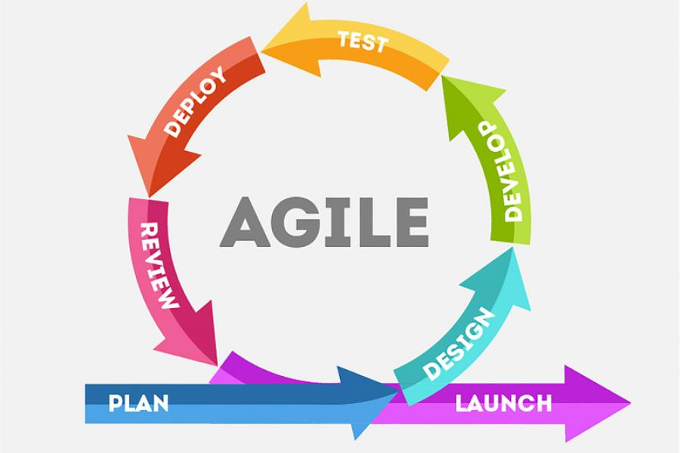

Figure : Agile development framework

## **3.3 Tools and Frameworks:**

This section provides a brief overview of the various tools that will be utilized in the development of the Smart School Administrative System.

### **3.3.1 Machine Learning:**

**Python**:

Python is a popular high-level interpreted programming language that is easy to learn and has a lot of adaptability. Python was developed by Guido van Rossum and initially published in 1991. Since then, it has grown to be one of the most commonly used programming languages worldwide, with applications in a variety of fields including scientific computing, web development, data analysis, and artificial intelligence.

**Numpy:**

is a library for the Python programming language, adding support for large, multi-dimensional arrays and matrices, along with a large collection of high-level mathematical functions to operate on these arrays [16]. Numerous mathematical operations on arrays can be carried out with NumPy. It provides an extensive library of high-level mathematical functions that operate on these arrays and matrices, and it enhances Python with strong data structures that ensure effective calculations with arrays and matrices.

**Pandas:**

Pandas is a software library written for the Python programming language for data manipulation and analysis. In particular, it offers data structures and operations for manipulating numerical tables and time series [16]. Pandas handles its data in native datatypes known as DataFrames and Series

Pandas offers functionality for:

* **Data Loading:**

Pandas provides functionality for reading data in CSV, Excel, JSON, SQL database formats. It also provides functions for writing back into those formats

* **Data Manipulation:**

A multitude of data manipulation features are available with Pandas, such as the ability to choose, filter, group, merge, join, and reshape data. These processes are carried out effectively, even with big datasets.

* **Data Cleaning:**

Pandas provides methods for handling missing data removing duplicates, and performing data normalization and transformation.

* **Data Visualization Integration:**

While Pandas itself doesn't offer visualization capabilities, it integrates well with other libraries like Matplotlib and Seaborn for data visualization. Data stored in Pandas DataFrames can be easily plotted using these libraries.

**Scikit-Learn:**

scikit-learn is a free and open-source machine learning library for the Python programming language. It features various classification, regression and clustering algorithms including support-vector machines, random forests, gradient boosting, *k*-means and DBSCAN, and is designed to interoperate with the Python numerical and scientific libraries NumPy and SciPy [16].

Listed below are some of the key features of Scikit-Learn:

* **Simple and Consistent API:**

Implementing machine learning algorithms and models is made straightforward by Scikit-learn's unified and user-friendly API. Users can experiment with different ways more easily because diverse algorithms are consistent with one another.

* **Wide Range of Algorithms:**

A huge range of machine learning methods for preprocessing, model selection, dimensionality reduction, clustering, regression, and classification are included in Scikit-learn. Code that is optimized and efficient is used to implement these techniques.

* **Model Evaluation and Validation:**

Scikit-learn offers functions for cross-validation, model selection, hyperparameter tuning, and computation of performance metrics, among other tools for assessing and validating machine learning models.

* **Feature Extraction and Preprocessing:**

Scaling, normalization, encoding categorical variables, feature selection, and other preprocessing and feature extraction methods are all provided by Scikit-learn.

### **3.3.2 UI Design:**

UI design, short for User Interface design, is the process of designing the visual layout and interactive elements of digital interfaces to optimize user experience and satisfaction. It focuses on creating interfaces that are intuitive, aesthetically pleasing, and efficient to use.

**Figma:**

Figma is a cloud-based design and prototyping tool that allows teams to collaborate on UI/UX design projects in real-time. It's known for its ease of use, collaborative features, and versatility. Listed below are some of the prominent features of Figma:

* **Real-time Collaboration:**

Figma allows for multiple designers at different remote locations to work on the same files at the same time. This fosters collaboration and reduces communication overhead.

Developers also have real-time access to the design files, speeding up development

* **Vector Editing:**

Figma offers robust vector editing features. Vector objects, text, and images are easily created, edited, and manipulated by users.

* **Prototyping:**

Figma allows designers to create interactive prototypes directly within the design tool. Users can define clickable hotspots, transitions, and animations to simulate user flows and interactions.

This is very useful to developers who are responsible for the design implementation.

### **3.3.3 Frontend Development:**

Frontend development, sometimes referred to as client-side development, is the process of creating a website or online application's user interface (UI) and user experience (UX). The visible portions of a website that people interact with directly in their web browsers are made by frontend developers.

The primary tool for frontend development in this project is Next.js.

**Next.js**:

Next.js is an open-source web development framework built on top of React that simplifies building fast and performant web applications. In addition to its modular nature, a feature derived from the react framework, Next.js also inherently supports Server-Side Rendering (SSR). In web development, server-side rendering (SSR) is a technique where the web page content is generated on the server in response to a user's request, instead of being generated in the user's web browser as seen in basic React. SSR allows for faster initial page load speeds which goes a long way to improve user experience.

Some other essential features of Next.js are:

* **Routing:**

Next.js uses a file-based routing system. Each page in your application corresponds to a file within a specific directory structure. This makes routing intuitive and easy to manage.

* **Data Fetching:**

Mechanisms for retrieving data from external databases or APIs are provided by Next.js. Data can be fetched during hydration (population of web pages with content) on the client side or at build time (SSG).

* **Automatic Code Splitting:**

Next.js automatically splits your codebase into smaller bundles, ensuring only the necessary code is loaded for each page. This improves initial load times and overall performance.

### **3.3.4 API Management:**

**Express.js:**

Express.js, often shortened to Express, is a popular open-source web framework built on top of Node.js. It's essentially a tool that simplifies building web applications and APIs using JavaScript on the server-side.

Some of the major features of Express.js are:

* **Routing:**

Express.js is a great tool for creating routes for your program. These routes associate URLs with particular user request handling functions. This facilitates the organization of your application and the effective management of its various components.

* **Middleware:**

A powerful concept in Express is middleware. Middleware functions are essentially functions that have access to the request object, response object, and the next middleware function in the chain. You can use middleware for various purposes like logging requests, parsing incoming data, or handling authentication

### **3.3.5 Database Management:**

Considering the large number of relationships that exists between the entities within the Smart School Administrative System’s database, a relational database approach was adopted.

**PostgreSQL:**

PostgreSQL, often abbreviated as Postgres, is a powerful, open-source object-relational database management system (ORDBMS) known for its reliability, feature richness, and performance.

Some of its notable features are:

* **Object-Relational:**

Through the use of object-oriented features, PostgreSQL surpasses the capabilities of conventional relational databases. This increases the versatility of data modeling by enabling you to design sophisticated data types and make use of object-oriented programming ideas within the database.

* **ACID Compliant:**

PostgreSQL ensures data integrity through ACID (Atomicity, Consistency, Isolation, Durability) properties. This guarantees that database transactions are completed reliably and consistently, preventing data corruption

## **3.4 Application Flow:**

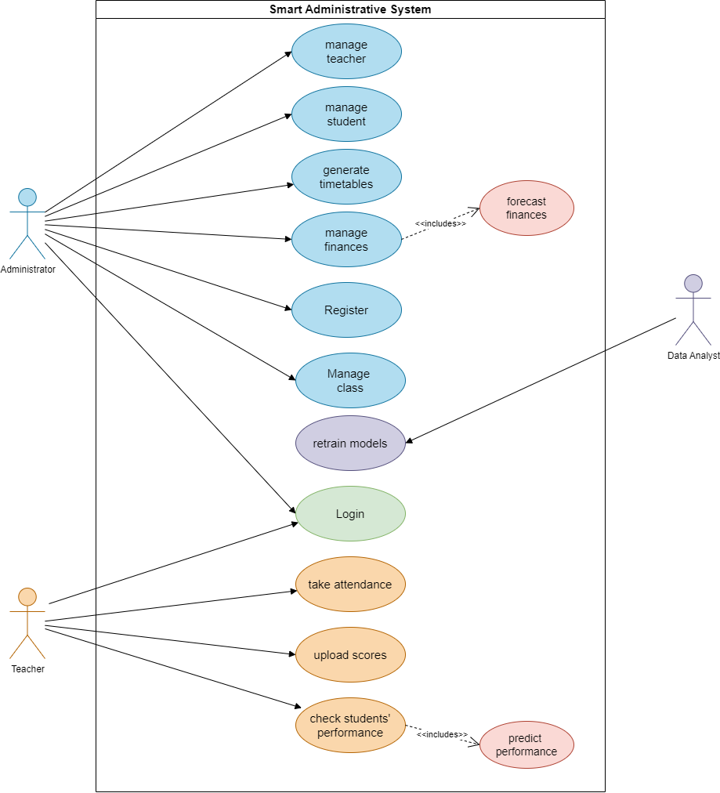

Figure : UML Use case diagram for Smart School Administrative System

As can be seen from the diagram, there are three main actors (or users) that are concerned with the system, the school administrator, teachers and the data analyst.

**Administrator:**

Administrators are responsible for the overall management of the school’s data. They are responsible for adding students who enroll and removing those who leave the school. They can also edit the data of any student to make it up to date with the student’s current status. The administrator is also able to observe each student’s performance along with their likely future performance.

Staff management also lies in the hands of the administrator. They can add or remove teachers or their edit data. They can also observe the performance of teachers.

The administrator also handles financial data of the school. The administrator would be able to track the tuition fee payment status of each student as well as monitor the total amount of funds that the school has in its coffers.

**Teacher**:

Teachers also perform some sort of student management. But this is mainly concerned with uploading student scores and taking their attendance. Teachers can also monitor the performance of students as well as their likely future performance. This will give them insights into which students require more attention, and hence lead to improvement of the class as a whole.

**Data Analyst:**

As time goes on, more and more data gets collected. The role of the data analyst is to use this new data to retrain the machine learning models. This is very essential to the performance of the system, as machine learning models tend to do better with more data.

## **3.5 Database Overview:**

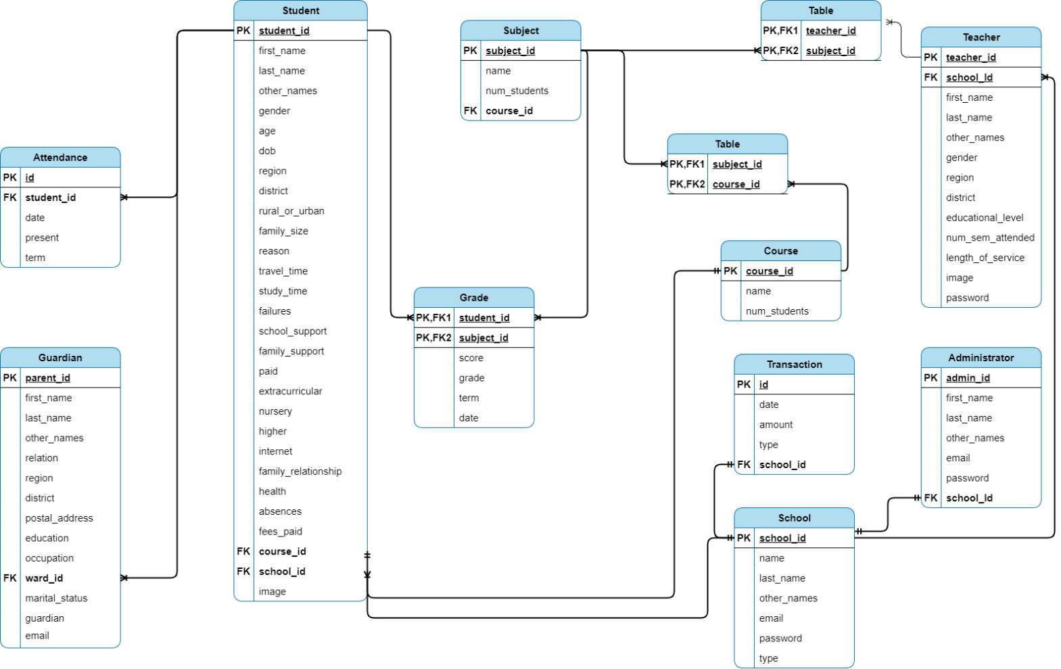

Figure Database schematic for Smart School Administrative System

The data tables, especially those for students and teachers are made to represent the research findings.

## **References**

[1] Leithwood, Kenneth, et al. "How successful leadership influences student learning: The second installment of a longer story." *Second international handbook of educational change* (2009)

[2] Bonabeau, Eric. "Don't trust your gut." *Harvard business review* 81.5 (2003): 116-23.

[3] Klein, Gary. "Naturalistic decision making." *Human factors* 50.3 (2008): 456-460.

[4] Simon, Herbert A. "Making management decisions: The role of intuition and emotion." *Academy of Management Perspectives* 1.1 (1987): 57-64.

[5] Bhat, Mushtaq Ahmad, Jyotsna Joshi, and Irfan Ahmad Wani. "Effect of socio economic status on academic performance of secondary school students." *The International Journal of Indian Psychology* 3.4 (2016): 32-37.

[6] Harmon, Maryellen, et al. "Performance assessment in IEA’s third international mathematics and science study." *Center for the Study of Testing, Evaluation and Education Policy, Boston College, Boston* (1997).

[7] Hirokawa, Sachio. "Key attribute for predicting student academic performance." *Proceedings of the 10th International Conference on Education Technology and Computers*. 2018.

[8] S. Patel and B. Lee, "The Role of Home Environment in Student Academic Achievement: A Longitudinal Study," IEEE Educ. Technol. Soc. Mag., vol. 19, no. 1, pp. 78-91, Apr. 2019.

[9] D. Smith et al., "The Impact of Data-Informed Decision Making on Organizational Performance: A Meta-Analysis," Journal of Management, vol. 45, no. 3, pp. 567-580, Mar. 2020.

[10] R. Johnson and A. Brown, "Data-Informed Strategic Planning: Best Practices and Case Studies," Strategic Management Journal, vol. 40, no. 2, pp. 45-58, Jun. 2019

[11] L. Garcia and C. White, "Utilizing Data for Evidence-Based Decision Making in Education: Challenges and Opportunities," IEEE Educ. Technol. Soc. Mag., vol. 22, no. 1, pp. 78-91, Jan. 2021.

[12] A. Johnson et al., "The Impact of Professional Development on Teacher Performance: A Meta-Analysis," IEEE Trans. Educ., vol. 42, no. 3, pp. 567-580, Aug. 2020.

[13] K. Brown et al., "Classroom Environment and Teacher Performance: A Multilevel Analysis," IEEE Trans. Learn. Technol., vol. 18, no. 4, pp. 321-335, Nov. 2019.

[14] A. Johnson et al., "The Influence of Teacher Experience on Performance: A Longitudinal Study," IEEE Trans. Educ., vol. 45, no. 1, pp. 567-580, Jan. 2021.

[15] K. Brown et al., "The Impact of Teacher Age on Performance: A Comparative Study," IEEE Trans. Educ., vol. 40, no. 4, pp. 321-335, Apr. 2021.

[16] Wikipedia

[17] United Nations Economic Commission for Africa (UNECA), "Africa Data Revolution Report 2019: Strengthening the Data Ecosystem for Sustainable Development," 2019.

[18] Global Partnership for Education (GPE), "GPE's Approach to Data and Results Monitoring," 2019.